**Router 结构概览**

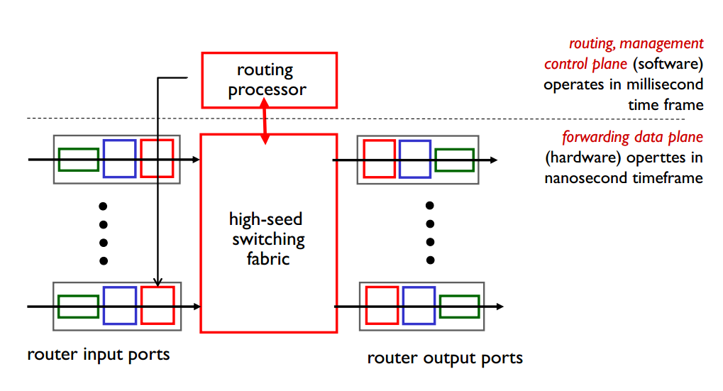

**Input port functions**

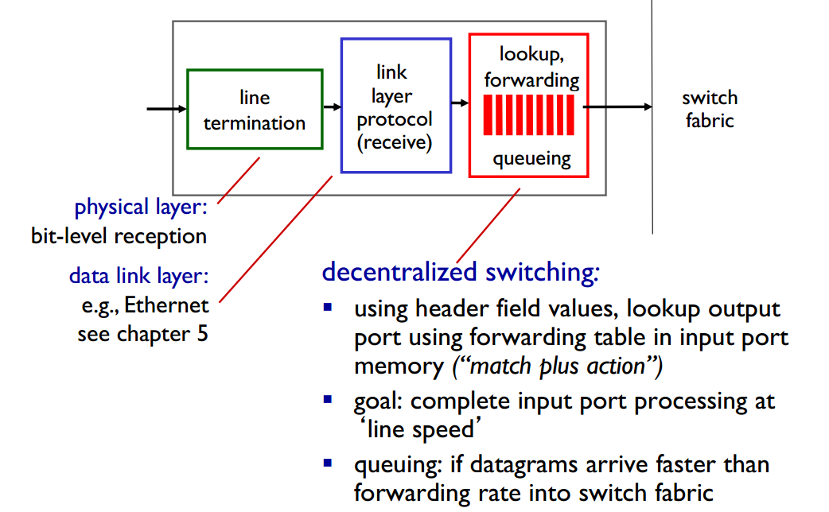

**Destination-based forwarding**

longest prefix matching：when looking for forwarding table entry for given destination address, use **longest address prefix** that matches destination address

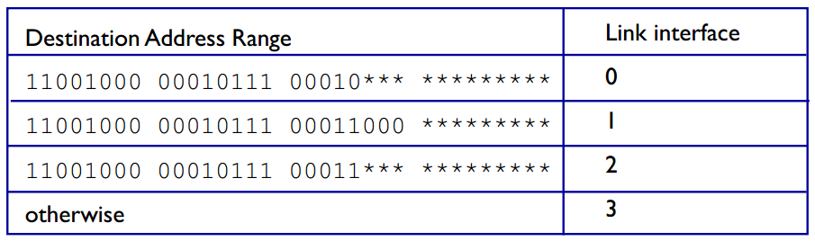

**Switching fabrics交换网络**

将数据包从输入缓冲区传输到适当的输出缓冲区

交换速率:包从输入到输出的传输速率

often measured as multiple of input/output line rate

N inputs: switching rate N times line rate desirable

three types of switching fabrics

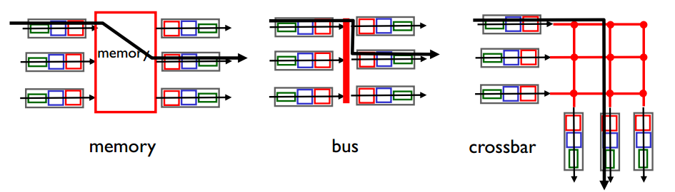

**Output Ports**

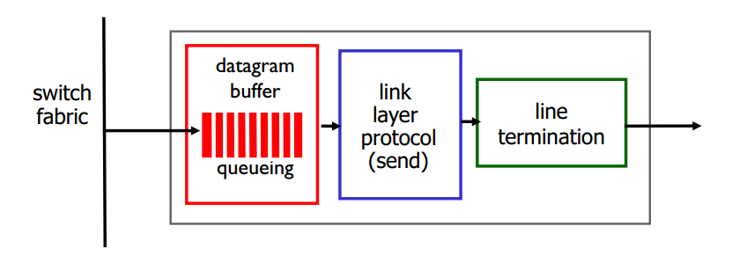

buffering required when datagrams arrive from fabric faster than the transmission rate

当数据报从fabric到达的速度快于传输速率时，需要缓冲

scheduling discipline chooses among queued datagrams for transmission line termination link layer protocol (send) switch fabric

Priority scheduling – who gets best performance, network neutrality

数据报会因为拥塞和lack of buffer 而丢失

**Output port queueing**

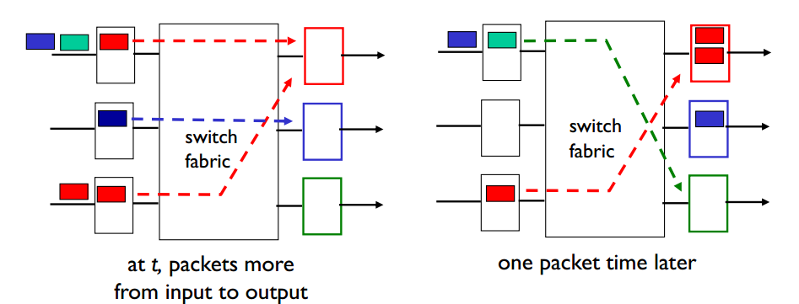

当通过switch的到达率超过输出line speed时进行缓冲

queueing (delay) and loss due to output port buffer overflow!

**How much buffering?**

RFC 3439 rule of thumb: average buffering equal

to “typical” RTT (say 250 msec) times link

capacity C

e.g., C = 10 Gpbs link: 2.5 Gbit buffer

recent recommendation: with N flows, buffering

equal to

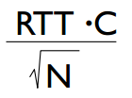

**Scheduling mechanisms**

scheduling: choose next packet to send on link

FIFO (first in first out) scheduling: send in order of arrival to queue

discard policy: if packet arrives to full queue: who to discard?

tail drop: drop arriving packet

priority: drop/remove on priority basis

priority: drop/remove on priority basis